

TITLE

An Internship Report (18EC74)
Submitted by,
NAME USN

Under the guidance of
Guide
designation
Dept. of ECE

RV College of Engineering

In partial fulfillment of the requirements for the degree of Bachelor of Engineering in
Electronics and Communication Engineering 2022-23




RV College of Engineering®, Bengaluru

(Autonomous institution affiliated to VTU, Belagavi )
Department of Electronics and Communication Engineering

.

CERTIFICATE

Certified that the Internship titled internship title is carried out by name & usn who is bonafide student of RV College of Engineering, Bengaluru, in partial fulfillment of the requirements for the degree of Bachelor of Engineering in Electronics and Communication Engineering of the Visvesvaraya Technological University, Belagavi during the year 2022-23. It is certified that all corrections/suggestions indicated for the Internal Assessment have been incorporated in the report deposited in the departmental library. The report has been approved as it satisfies the academic requirements in respect of minor project work prescribed by the institution for the said degree.

Guide | Head of the Department | Principal
Dr. Shilpa D.R | Dr. H V Ravish Aradhya | Dr. K N Subramanya

External Viva

Name of Examiners Signature with Date

1.

2.

DECLARATION

I, name students of seventh semester B.E., Department of Electronics and Communication Engineering, RV College of Engineering, Bengaluru, hereby declare that the Internship/ Industrial training titled ‘title’ has been carried out by me and submitted in partial fulfilment for the award of degree of Bachelor of Engineering in Electronics and Communication Engineering during the year 2022-23.

Further I declare that the content of the dissertation has not been submitted previously by anybody for the award of any degree or diploma to any other university.

I also declare that any Intellectual Property Rights generated out of this work carried out at RVCE will be the property of RV College of Engineering, Bengaluru and we will be one of the authors of the same.

Place: Bengaluru Date:

Name Signature

1. NAME & USN

ACKNOWLEDGEMENT

I am indebted to my guide, NAME, Associate Professor, RV College of Engineering . for the wholehearted support, suggestions and invaluable advice throughout my project work and also helped in the preparation of this thesis.

I also express our gratitude to my examiner NAMES, Assistant Professor, RV College of Engineering for her valuable comments and suggestions during the phase evaluations.

My sincere thanks to the internship coordinators NAMES for their timely instructions and support in coordinating the internship.

My sincere thanks to Dr. H V Ravish Aradhya, Professor and Head, Department of Electronics and Communication Engineering, Vice Principal, RVCE for the constant support and encouragement.

I express sincere gratitude to our Principal, Dr. K N Subramanya for the appreciation towards this internship work.

I thank all the teaching staff and technical staff of Electronics and Communication Engineering department, RVCE for their help.

Lastly, I take this opportunity to thank my family members and friends who provided all the backup support throughout the internship work.

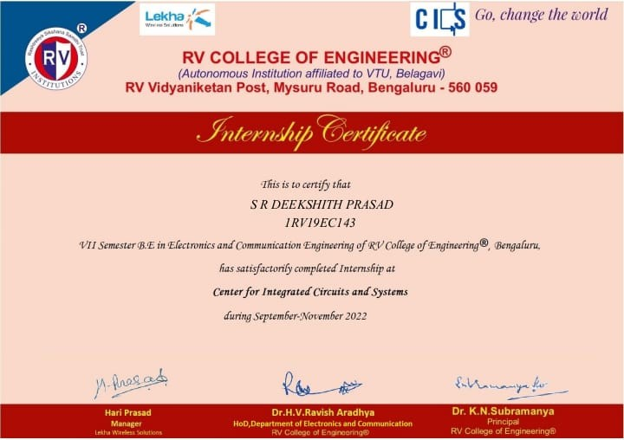

Certificate of Completion

SYNOPSIS

CONTENTS

Synopsis

List of Figures Abbreviations
1 Profile of the organization
2 Activities of the Department
3 Tasks performed

- Reflections 36

LIST OF FIGURES

ABBREVIATIONS

Chapter 1
Profile of the organization

CHAPTER 1
PROFILE OF THE ORGANIZATION

Chapter 2
Activities of the Department

CHAPTER 2
ACTIVITIES OF THE DEPARTMENT

Chapter 3
Tasks performed

CHAPTER 3
TASKS PERFORMED

Chapter 4
Reflections

CHAPTER 4
REFLECTIONS

BIBLIOGRAPHY

